**Optical isomerism in compounds without chiral carbon**

Compounds containing a chiral carbon are optically active. However, there exist some compounds which do not possess a chiral atom but are optically active provided that the molecule is dissymmetric

**ALLENE DERIVATIVES**

Some derivatives of allenes **(CH2=C=CH2)** exhibit optical isomerism.

Example is I,3-diphenylpropadiene. In allenes, the central carbon forms **two sp-sp2 sigma bonds**. The central carbon has also **two p-orbitals** which are mutually perpendicular. These form pi-bonds with the p-orbitals on the other carbon atoms. As a result, the substituents at one end of the molecule are in plane which is perpendicular to that of the substituents at the other end, so that the compound exists in two forms which are non-superimposable mirror images and are optically active.

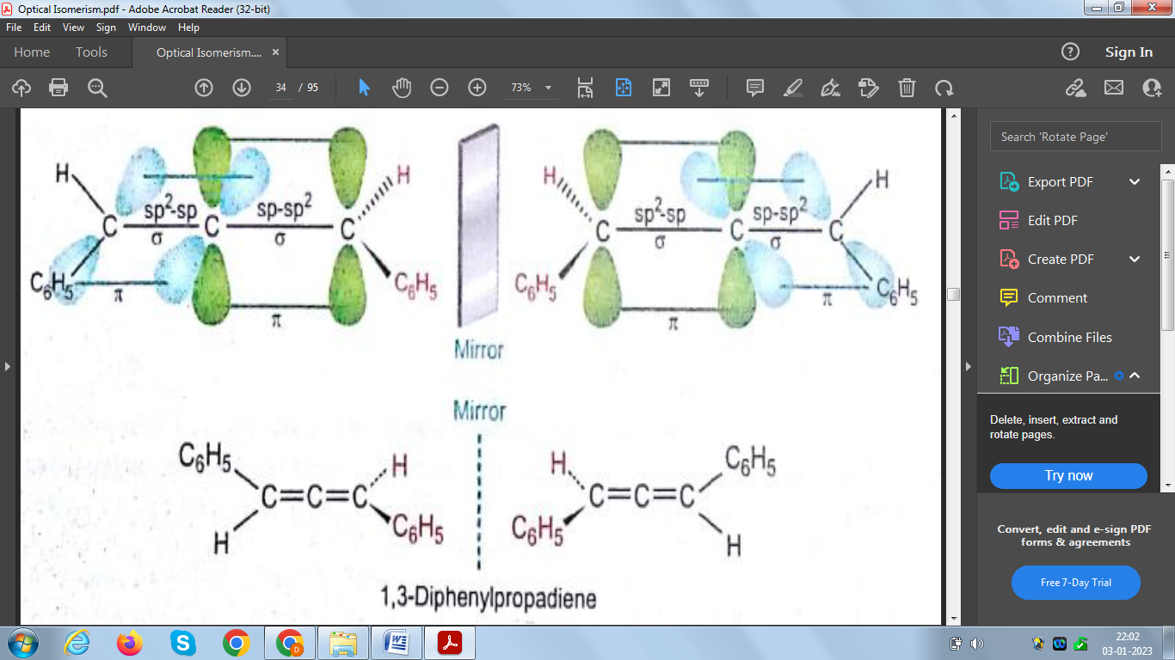

**BIPHENYL DERIVATIVES**

Substituted biphenyls show optical isomerism when substituents in the 2-positions are large

enough to prevent rotation about the bond joining the two benzene rings.

For example, biphenyl- 2, 2’ - disulphonic acid exist in two forms.



These two forms are non superimposable mirror images.They do not interconvert at room

temperature because the energy required to twist one ring through 180 angle relative to the other is too high. This in turn is because, during the twisting process, the two -SO3H groups must come into very close proximity when the two benzene rings become coplanar and strong repulsive forces are introduced

**Geometrical isomerism**

The isomers which are having same structural formula but are differing in spatial

arrangement of the groups or atoms around the double bond are termed as geometrical

isomers and the phenomenon is termed as geometrical isomerism.

Example:

- Two different spatial arrangements of methyl groups about a double bond in 2-butene give

Rise to the following geometrical isomers.

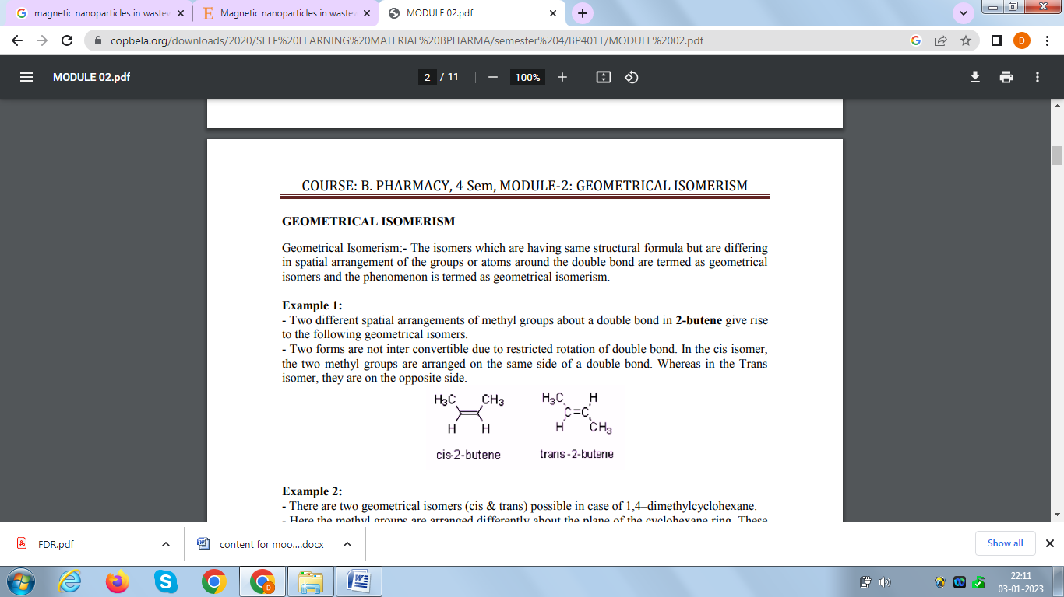

- Two forms are not inter convertible due to restricted rotation of double bond. In the cis

isomer, the two methyl groups are arranged on the same side of a double bond. Whereas in

the Trans isomer, they are on the opposite side.

**E & Z notation for geometric isomerism**

cis/trans descriptors is not sufficient when there are more than two different substituents on a

double bond. To differentiate the stereochemistry in them, a new system of nomenclature

known as the E & Z notation method is to be adopted.

**The following procedure** is to be adopted to denote the geometrical isomers by E & Z

descriptors.

If the groups with higher priorities are present on the opposite sides of the double bond, that

isomer is denoted by E. Where E = Entgegen ( the German word for 'opposite' ) or E=Enemy

However if the group with highest priority is on the same side of the double bond, that isomer

Is Denoted by Z. Where Z = Zusammen (the German word for 'together')

E and Z are represented within parentheses and are separated from the rest of the name with a

hyphen.

**The priorities are assigned by following Cahn-Ingold-Prelog sequence rules:**

Rule 1: Rank the atoms directly attached to the olefinic carbon according to their atomic number. High priority is given to the atom with higher atomic number. 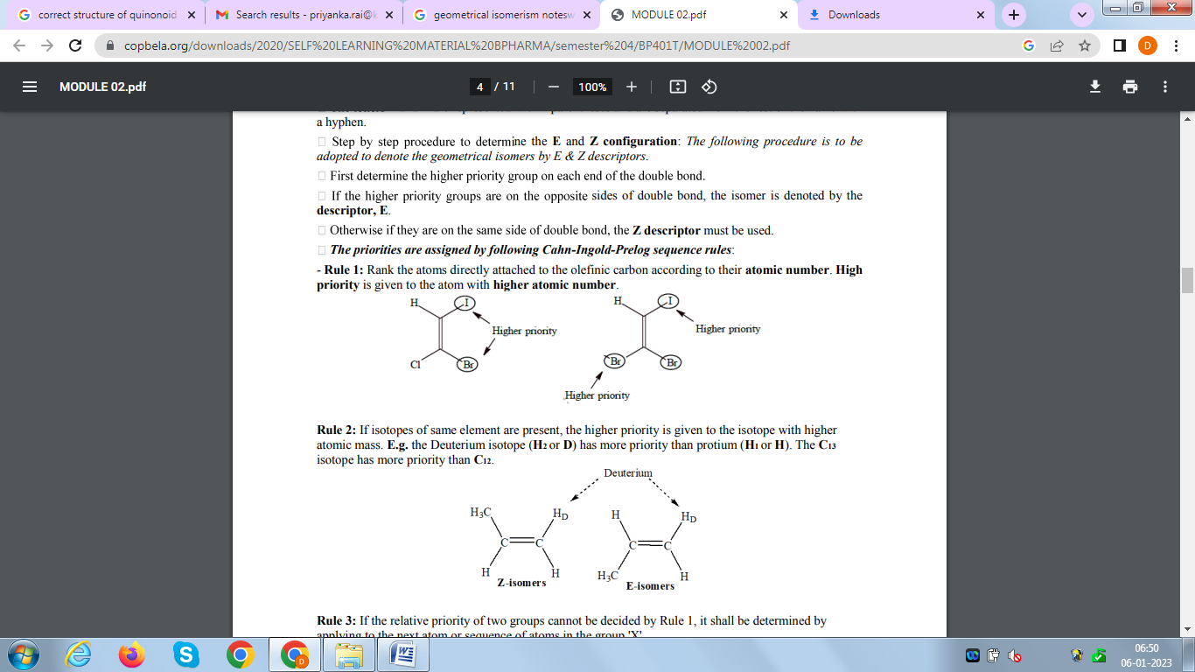

Rule 2: If isotopes of same element are present, the higher priority is given to the isotope with higher atomic mass. E.g. the Deuterium isotope (H2 or D) has more priority than protium (H1 or H). The C13 isotope has more priority than C12.



Rule 3: If the relative priority of two groups cannot be decided by Rule 1, it shall be determined by applying to the next atom or sequence of atoms in the group 'X'.

X = -CH2CH2CH3 > -CH2CH3 > -CH3 > -H i.e. the longer the hydrocarbon carbon chain the higher its priority.

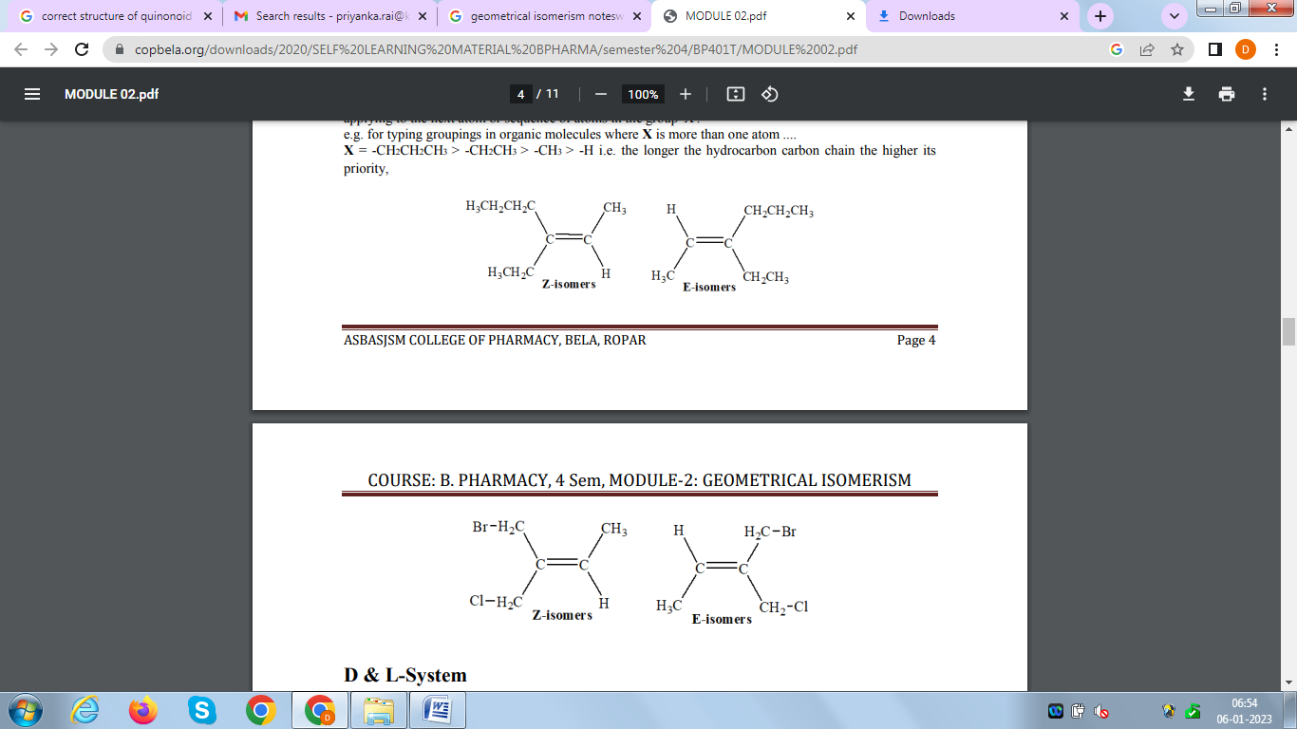



**Chiral Drugs**

The existence of differences in the biological activities of enantiomers or diastereoisomers has been known for over 100 years. In 1886, Piutti described the isolation of the enantiomers

of asparagine and noted differences in the taste associated with the two isomers.

About more than half of the drugs currently in use are chiral compounds and near 90% of the

last ones are marketed as racemates consisting of an equimolar mixture of two enantiomers.

Although they have the same chemical structure, most isomers of chiral drugs exhibit marked

differences in biological activities such as pharmacology, toxicology, pharmacokinetics, metabolism etc.

In the 2001 **Nobel Prize** in Chemistry has been awarded to three scientists:Dr. William S. Knowles and Pr. K. Barry Sharpless in USA and Pr. Ryori Nyori in Japan, for their development of asymmetric synthesis using chiral catalysts in the production of single enantiomer drugs or chemicals.

The enantiomers of a chiral drug differ in their interactions with enzymes, proteins, receptors and other chiral molecules too including chiral catalysts. These differences in interactions, in turn, lead to differences in the biological activities of the two enantiomers, such as their pharmacology, pharmacokinetics, metabolism, toxicity, immune response etc. Surprisingly, biological systems can recognize the two enantiomers as two very different substances.

**But why do enantiomers have different biological activities?**

Biological systems like that of human beings have been known to exhibit chirality. This is

reflected by the existence of chirality of drug receptor areas and the requirement of chiral specificity on drugs.

In order to understand the biological effect of drugs, we have to distinguish the **three main phases of their action**. The first phase is the initial receptor differentiation phase, where different drugs have different affinity and tissue specificity due to receptor differentiation and distribution for the parent compound formed. The second phase is the absorption, distribution, metabolism and excretion phase, where the type of bioavailability is determined. The third phase is the interaction of the drug with the molecular site of action, leading to the observed.

The three phases of action are based on the **receptor theory**, similar to the lock-and-key hypothesis proposed by the famous scientist Emil Fischer. Receptor molecules in the body are proteins that exhibit high affinities for the binding of molecules with certain structures. This is completely analogous to enzyme-substrate binding. Mismatching of drug molecules with the targeted receptors may cause undesirable side effects such as requirement of higher dosage and increased toxicity.

All pharmacological activity may reside in one enantiomer. The therapeutic inactive isomer is regarded as an impurity that possesses a different or undesirable pharmacological entity. This situation may become even more acute if the active enantiomer exhibits a low therapeutic value or there is clinically significant toxicity.

Enantiomer ratio is extremely important because while one enantiomer is beneficial to the body, the other enantiomer can be highly toxic to the body. A well-known example of enantiomer related toxicity is the *R- and S-enantiomers of thalidomide***.**

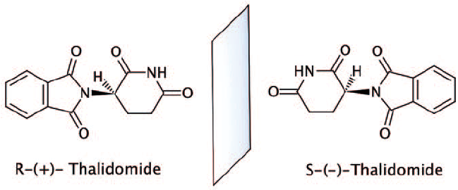

The R-enantiomer is an effective sedative, which has a soothing effect that relieves anxiety and makes the patient drowsy; while, the S-enantiomer is known to cause teratogenic birth defects. A teratogenic fetus is one with deficient, redundant, misplaced or grossly misshapen parts.

**Recognition of chiral drugs by specific drug receptors is explained by a *three-Point interaction of the drug with the receptor site, as proposed by Easson and Stedman*.** The difference between the interaction of the two enantiomers of a chiral drug with its receptor is

illustrated below.

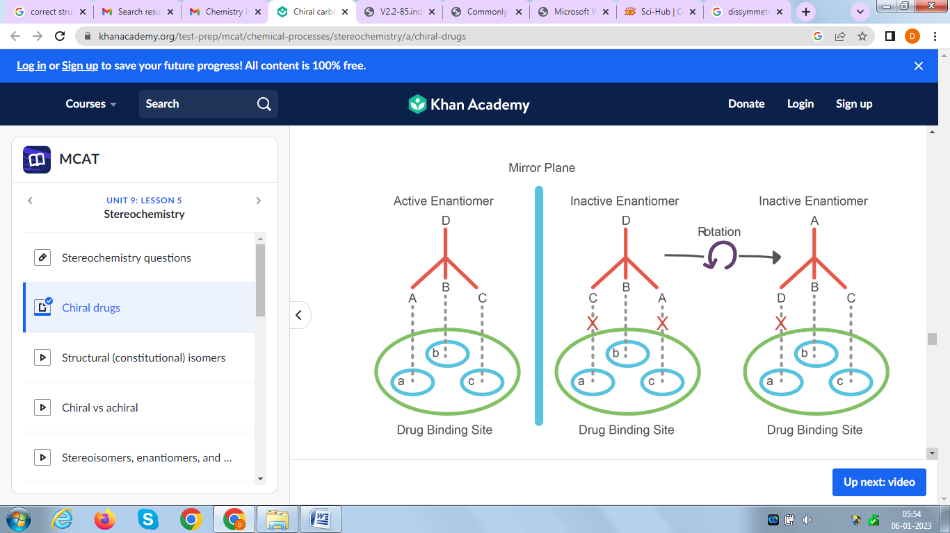

The three substituents A, B, C of the active enantiomer (left) can interact with three binding sites a, b, c of a receptor by forming three contacts Aa, Bb and Cc, whereas the inactive enantiomer (right) cannot because the contact is insufficient.In this case, one enantiomer is biologically active while the other enantiomer is not.

***Only a particular enantiomer that has a complementary shape to the receptor site can fit into a receptor site, will be biologically active.***

**Few examples of chiral drugs, whose enantiomers vary drastically in their properties:**

1. Human olfactory sensory organs are chiral, so the following pair of enantiomers smell very differently to us. R-isomer of carvone smells like spearmint leaves, while S-isomer of carvone smells like caraway seeds.

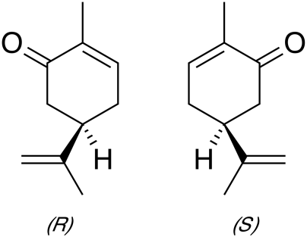

1. In the case of the well-known painkiller, ibuprofen, the (S)-enantiomer has the desired

pharmacological activity while the (R)-enantiomer is totally inactive.

